**Assignment-3**

Total sales per product.

db.sales.aggregate([{$group:{_id: ”$product”,totalSales:{$sum:{$multiply:[“price”,”quantity ”]}}}}])



Total revenue per product.

db.sales.aggregate([{$group:{_id:"product",TotalSales:{$sum:{$multiply:["$price","$quantity"]}}}}])

[ { _id: 'product', TotalSales: 15650 } ]



Total revenue per category.

db.sales.aggregate([

{

$group: {

_id: "$category",

totalRevenue: { $sum: { $multiply: ["$price", "$quantity"] } }

}

}

])



Count of products per category.

db.sales.aggregate([

{

$group: {

_id: "$category",

count: { $sum: 1 }

}

}

])



Store-wise total sales.

db.sales.aggregate([

{

$group: {

_id: "$store",

totalSales: { $sum: { $multiply: ["$price", "$quantity"] } }

}

}

])

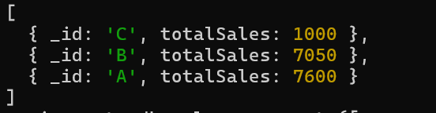

Average price of products per category.

db.sales.aggregate([

{

$group: {

_id: "$category",

avgPrice: { $avg: "$price" }

}

}])

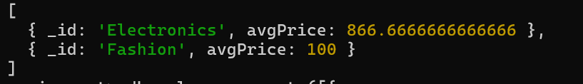

Top-selling product.

db.sales.aggregate([{

$group: {_id: "$product",

totalSales: { $sum: "$quantity" }}},

{$sort: { totalSales: -1 }},

{$limit: 1}])



Total sales for Electronics category.

db.sales.aggregate([ {

$match: {category: "Electronics" } },

{ $group: { _id: "Electronics",

totalSales: { $sum:{$multiply:["$price","$quantity"] }

}}}] )



Sales trend over time (day-wise total sales).

db.sales.aggregate([

{

$group: {

_id: { $dateToString: { format: "%Y-%m-%d", date: "$date" } },

totalSales: { $sum: { $multiply: ["$price", "$quantity"] }

}

}

])

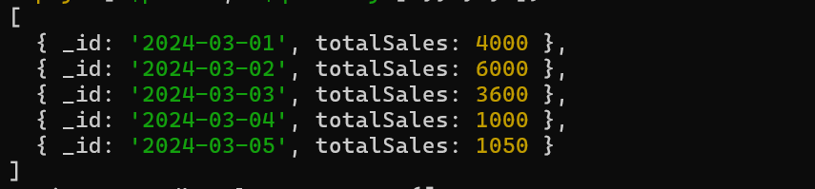

Highest revenue-generating product.

db.sales.aggregate([

{

$group: {

_id: "$product",

totalRevenue: { $sum: { $multiply: ["$price", "$quantity"] } }

}

},

{

$sort: { totalRevenue: -1 }

},

{

$limit: 1

}

])



Average revenue per sale.

db.sales.aggregate([ {

$project: { sales: { $multiply: ["$price", "$quantity"] } } },

{ $group: { _id: "category", avgSales: { $avg: "$sales" } }

}] )



Sales performance per store.

db.sales.aggregate([ { $group: { _id: "$store", totalsales: { $sum: { $multiply: ["$price", "$quantity"] } } } }] )



Products sold more than 5 times.

db.sales.aggregate([

{

$group: {

_id: "$product",

totalSales: { $sum: "$quantity" }

}

},

{

$match: { totalSales: { $gt: 5 } }

}

])



Least sold product.

db.sales.aggregate([

{

$group: {

_id: "$product",

totalSales: { $sum: "$quantity" }

}

},

{

$sort: { totalSales: 1 }

},

{

$limit: 1

}

])



Monthly sales summary.

db.sales.aggregate([

{

$group: {

_id: "$product",

totalSales: { $sum: "$quantity" }

}

},

{

$sort: { totalSales: 1 }

},

{

$limit: 1

}

])



Number of unique products sold.

db.sales.aggregate([

{ $group: {

_id: "product",

uniqueProducts: { $addToSet: "$product" }

}}, {

$project: {

uniqueProducts: { $size: "$uniqueProducts" } }

}])



Maximum and minimum priced product

db.sales.aggregate([

{

$group: {

_id: "price",

maxPrice: { $max: "$price" },

minPrice: { $min: "$price" }

} }])



Total revenue per product in descending order.

db.sales.aggregate([

{

$group: {

_id: "$product",

totalRevenue: { $sum: { $multiply: ["$price", "$quantity"] } }

}

},

{

$sort: { totalRevenue: -1 } }])

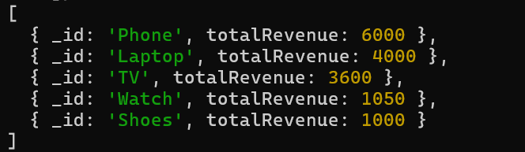

Revenue generated per store per category.

db.sales.aggregate([

{

$group: {

_id: { store: "$store", category: "$category" },

totalRevenue: { $sum: { $multiply: ["$price", "$quantity"] } }

}

}

])

